EMBEDDED SYSTEM AND DESIGN
EXPERIMENT NO. 6

AUTOMATIC TRASH CAN

Name: Raphael S. Nano

Course/Section: CPE160P / B1

Date of Performance: September 18, 2023
Date of Submission: September 20, 2023

Ma'am Cyrel Manlises
Instructor

DISCUSSION

Trash cans are simply the receptacle for scraps and the storage of wastes, which may be any kind of material like metals, plastic, glass, and other more. However, due to technological advances, even the most basic trash cans become automated. An automatic trash can may involve the opening of lid when a person tries to throw something in, sensing a person's hand when near the trash can, and the closing of the lid when the trash can is full. For this experiment, an automatic trash can was constructed and produced using a servo motor, a stepper motor, and an ultrasonic sensor. All are synchronized in order to close the lid when the trash can is full, and open the lid when the trash inside the can is pushed down.

The materials utilized to construct the automatic trash can are the Arduino UNO, an SG90 Servo motor, a 28BYJ-48 stepper motor, a motor driver module, 1 HC-SR04 ultrasonic distance sensor, 1 folder-created box that will serve as the trash can. For the code, external libraries Servo.h and Stepper.h were employed for the servo motor and stepper motor, respectively.
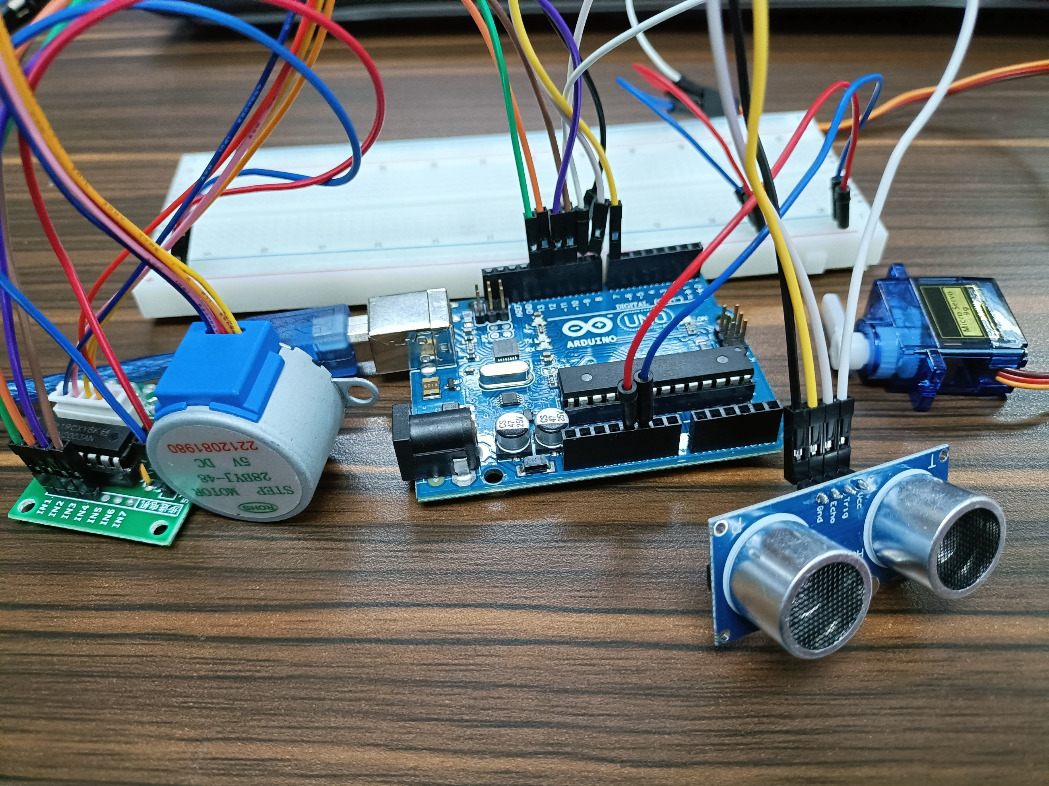

Figure 1. Materials for the Experiment

The sixth experiment primarily aims to demonstrate the automation system of a trash can whenever the container is full so that closing the lid and pushing the trash down ensures no overflow. Hence, the elements crucial for this experiment are the critical distance for the ultrasonic distance sensor, the movement of the stepper motor to close the lid, and the rotation of the servo motor to push the rubbish down.

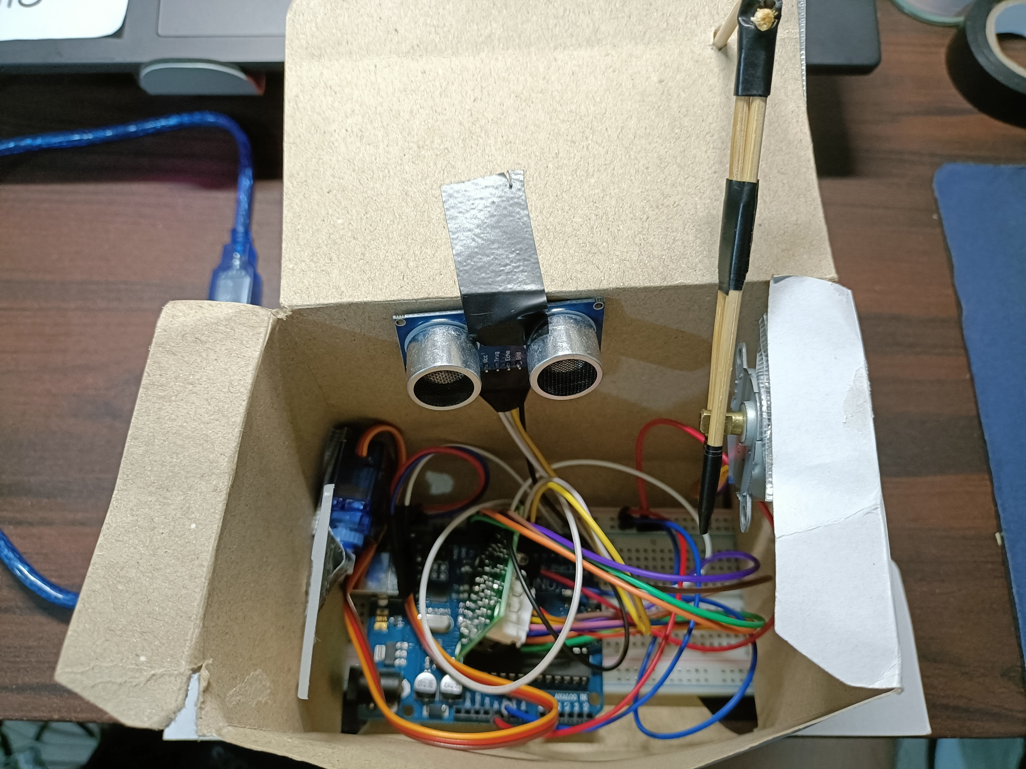

Figure 2. Final Output - Automatic Trash Can

For the ultrasonic distance sensor, a function named distance() was constructed. Within the function shown in Figure 3, the pins trig and echo of the ultrasonic distance sensor will be triggered. If the echo detects an object within the critical distance, which is computed by using the formula Distance = (s*t)/2, wherein s is the sound's speed 0.034 and t is the duration for the wave to bounce off the object. Estimating the distance between the sensor and the level of the trash can's capacity, the distance should be 5.

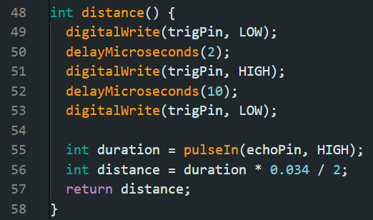

Figure 3. Code for distance() function

Both the servo motor and the stepper motor rotate when activated and both motors have a sturdy object connected so as to serve as a stopper or hinges. So, three functions were developed that are all dependent on the distance's condition. Exhibited in Figure 4, the closeCan() function, as the name implies, closes the lid of the trash can by rotating the stepper motor clockwise, making the cover go down. The openCan() function, on the other hand, opens the lid by rotating the stepper motor counter-clockwise, which makes the cover go up. Both of the these functions utilize the Stepper.h library. It contains pre-made functions such as "step" for the movement of the stepper motor and "setSpeed" for setting the motor's speed. A positive value for "step" will make the motor rotate clockwise, a negative value will make it rotate counter-clockwise. So, the motor's speed was set to 70, and the movement of the motor was set to 300 steps per call.
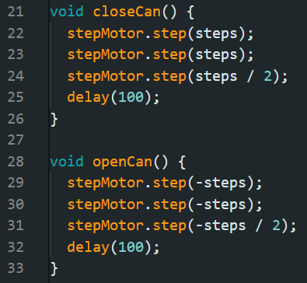

Figure 4. Code for closeCan() and openCan() functions

The pushDown() function, seen in Figure 5, is the module that commands the servo motor to move 120 degrees thrice, attempting to press the rubbish down by pushing the semi-lid, which is a hard plastic, downward. With a for loop, the servo motor is being constantly rewritten with an angle using the "write" function in order to go from 0 to 120 degrees and back.

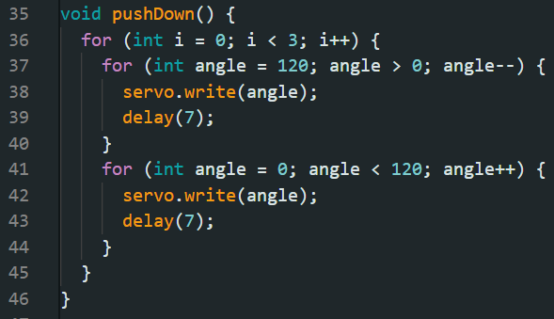

Figure 5. Code for pushDown() functions

Lastly, the loop of the program itself begins by checking if the critical distance was met. The checking of the distance was set to 5 seconds so that it would suggest that the height of the trash is constant - hence, the level is at its maximum. If the distance was met, closeCan() and pushDown() will be triggered. Afterwards, if the distance is still the same, then the lid should not be opened. The can will only be opened if trash is no longer at its maximum level to avoid overflow. Figure 6 shows the totality of the program loop for experiment 6.

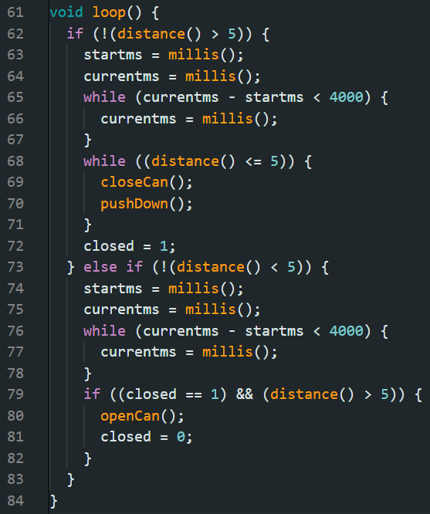

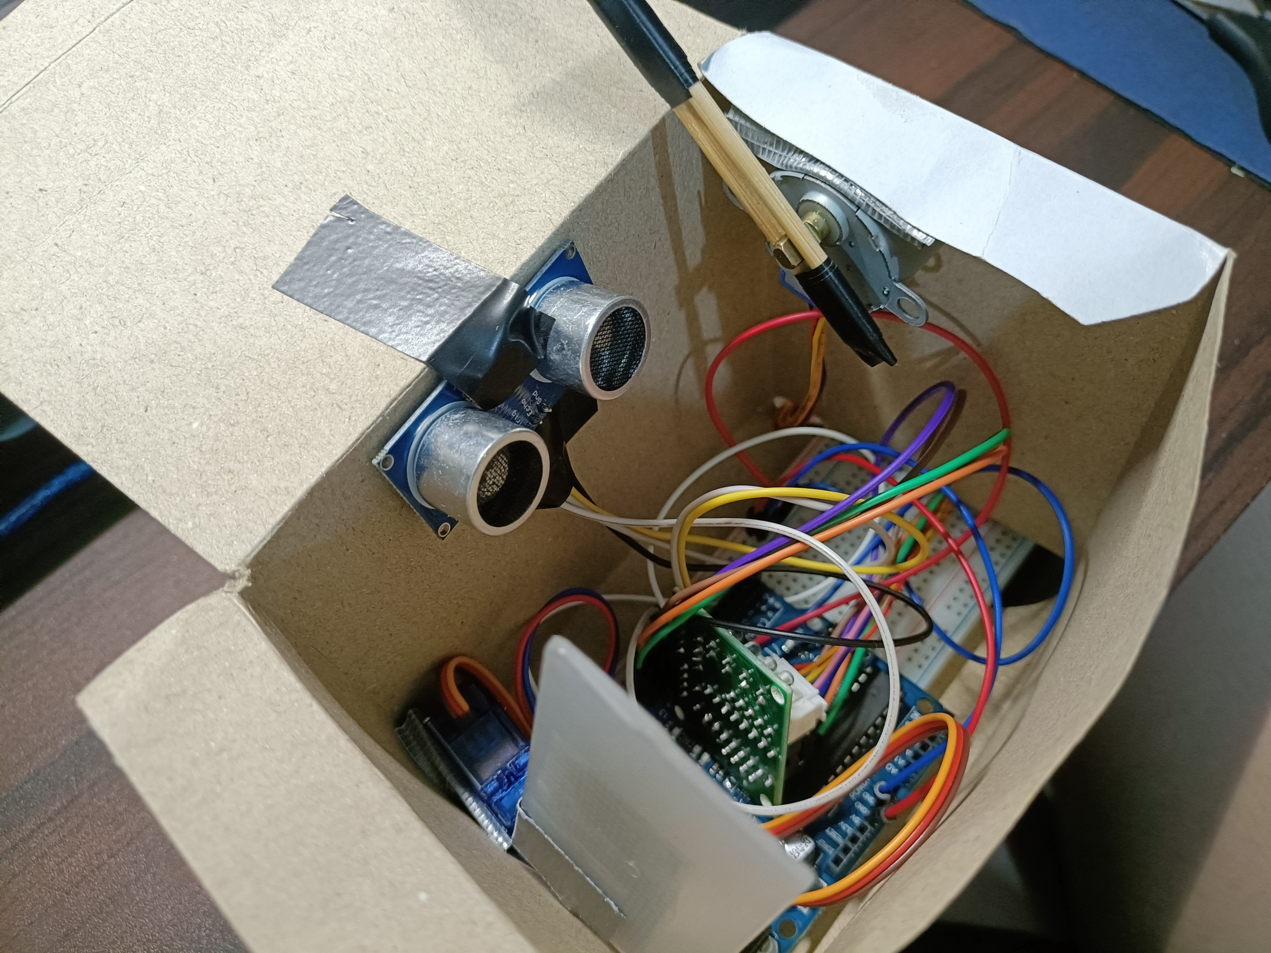
Figure 7. Setup with Trash Can
Figure 6. Experiment6 Program Loop
CONCLUSION
To conclude, for the first and second objectives, the automatic trash can works by closing the lid and pushing the trash down when it reaches the maximum height of the can, and it will only open if the trash is no longer at its maximum height, preventing overflow and maintaining the trash can's cleanliness. For the third goal, the stepper motor, which is coupled with sticks, spins clockwise so that it acts as a hinge that lowers the lid. The servo motor is the same. By moving the hinge clockwise, the rubbish is pushed down as well. The use of microprocessors, logic circuits, and switching theory is demonstrated through the series connections, pin layouts, and triggering of sensors and motors. As a result of using multiple variables, modules, and invoking such functions to construct an embedded system, the automated trash can was successfully constructed and demonstrated in a simple handshaking.

